Processing weather data with Apache spark to generate a RNN-LSTM for temperature forecasting at Knock Airport
Gavin M.Davis, CCT, Dublin

Abstract—Deep learning is becoming increasingly popular with the versatility and enhanced accuracy of these models taking the spotlight for generating the most accurate machine learning models available. Valuable data is being generated every second from multiple sources whether it be from social media sources, sensor data for traffic and climate fluctuations. This data given its magnitude is known as big data and poses a problem when it comes to deep learning, in that deep learning models themselves have yet to be connected fully to the platforms generated to handle big data such as Hadoop, MapReduce and Apache Spark. These distributed computing platforms are excellent at providing a way to store, process and query large datasets at enhanced speed. Taking Apache spark as an example, popular deep learning libraries like Keras and TensorFlow have yet to be fully connected to them, making running models like recurrent neural networks on big datasets difficult. Despite this drawback, Apache spark and its Sql library create a high-speed way to query big data, process, and generate dataframes which more complex neural networks can be modelled on. Considering this, this study aimed to harness Apache Spark to read in, process and query model data from Knock airport, sourced from data.gov, to illustrate how big data can be processed and queried for eventual implementation in deep learning models such as Recurrent Neural Networks (RNN). The SimpleRNN showed the highest accuracy, with an R²=0.9828 and RMSE=0.6186, compared to the LSTM model.

Keywords—RNN (Recurrent neural network), ANN (Artificial neural network), CNN (Convolutional neural network), RMSE ( Root mean square error), MSE (mean squared error)

Research Objectives

Harness the power of distributed computing using Apache spark to explore, prepare and process model big data based on airport weather measurements for the generation and comparison of RNN models for temperature prediction at Knock Aiport.

Evaluate, compare and discuss the state of the art in weather prediction models and big data and whether there are gaps and limitations to the use of big data in weather forecasting.

Introduction
1.Weather forecasting

The forecasting of weather is of great interest to the general public, business owners, event organisers, agricultural and transport authorities/operators, to name a few. The ability to accurately forecast weather at airport is even more important given the essential role weather plays in the organization of journeys and safety when it comes to air travel (Bochenek and Ustrnul, 2022). Air travel is sensitive to extreme weather and precautions must be implemented when planning in the industry. The prediction of meteorological data is of great benefit when considering this. Advanced machine learning techniques such as neural networks and an advanced ability to collect and organize data, leading to the generation of big data, provide a way to generate state of the art weather prediction models which could assist in planning and strategy for the day to day running of airports.

2.Big data: Where it comes from

Big data is the term given to the astronomical amounts of data collected daily in the modern world from multiple sources (Sagiroglu and Sinanc, 2013). The sheer magnitude of this data makes traditional tools for processing and analysing data near obsolete due to the time it would take for traditional methods to complete tasks on big data. There is a huge amount of power in big data to inform and discover trends amongst the world’s population. Big data comes from many sources one of the most notable being social media companies such as Twitter, Facebook, and Instagram, as well as sensor data for traffic in and out of cities or meteorological data collected from sensors on wind, rain, temperature, extending as far as clinical data from patients (Sagiroglu and Sinanc, 2013; Dash et al., 2019). This data takes the form of images, videos, text, and numbers but can all be used to glean valuable information from that particular sector it is collected. The value of this big data is slowly but surely being recognized and thus harnessed for its intrinsic value, being implemented into machine learning models for prediction, classification, and forecasting. One prominent application of Big data which is growing in popularity is forecasting (Tang et al., 2022). As seen in figure 1 the number of publications in relation to big data and forecasting has grown significantly since 2004.

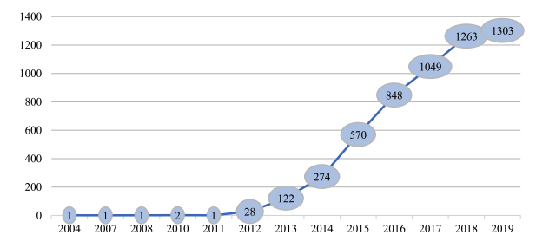
Figure 1: Highlighting yearly increase in publications centered around Big Data and forecasting (Tang et al., 2022).

Although forecasting using big data has rapidly grown over the past number of years, deep learning such as with Neural networks, which are the cutting edge of machine learning, pose a challenge in terms of connectivity. Some deep learning models are compatible with big data platforms such as Apache spark, however time series forecasting poses a significant challenge when it comes to distributed systems. It has been cited in many studies that the scalability and complexity of deep learning models when it comes to big data poses a problem despite the enhanced capacity for deep learning models to solve big data analytical issues (Najafabadi et al., 2015). Research in this area will be essential in the coming years to apply powerful deep learning techniques with big data platforms.

3.Apache spark

As previously mentioned, big data poses a problem for traditional data processing methods. Thus, platforms like Hadoop, MapReduce and Apache spark have been developed to help deal with issues in processing big data. Hadoop is an open source distributed management system for storing and processing big data, allowing the use of multiple nodes within a computing cluster to run analytical jobs, like sorting, analytics and data compression to name a few (What Is Hadoop & How Does It Work? | SAS Ireland, 2023). Apache spark, a distributed computing platform for handling big data, extends the power of MapReduce offering the ability to run computations in memory (Karau, 2015). Spark operates on the basis of the resilient distributed dataset (RDD) which is an immutable collection of objects divided across nodes of a computing cluster allowing parallel operations on the data in faster processing times than traditional methods (Karau, 2015). Apache spark offers a number of libraries for carrying out queries and analysis on big data which can be efficiently implemented through the use of pyspark allowing the writing of SQL-like commands for manipulating and processing big data in the distributed environment, thus reducing processing time (Karau, 2015; Bandi, Amudhavel and Karthik, 2018). This gives the user the ability to harness big data for analytics with the Apache spark platform even including some machine learning models through the libraries MLlib and Spark ML. However these libraries do not include many of the deep learning models which are commonly used thus highlighting a gap between the Apache spark and cutting edge machine learning models such as neural networks (Najafabadi et al., 2015).

4.Time series forecasting

Time series forecasting is a branch of data analytics which aims to use historical data collected and/or generated on a consistent periodic basis (hourly, monthly, yearly etc) to predict the future for that particular measurement (Deb et al., 2017). There are several applications of time series forecasting in areas such as stock market prediction, weather prediction, sentiment analysis and commodity pricing to name a few. There are many methods for time series forecasting including, but not limited to, Autoregressive moving average (ARIMA), Long short term memory neural networks (LSTM) and Gated recurrent unit (GRU) (Yamak, Yujian and Gadosey, 2019). All models have merit and are more suited to specific scenarios than the other leading to the requirement of experimentation. ARIMA uses observations from the previous time steps to predict the value in the next time step using regression, assuming that based on statistics the time series is stationary for a given variable, with the integrated component differencing the raw observations, and finally the moving average predicted by one or more of the lagged values of error (Schaffer, Dobbins and Pearson, 2021). LSTM and GRU are both based on recurrent neural networks. Recurrent neural networks are distinguished from artificial neural networks (ANN) and convolutional neural networks (CNN) by creating a relationship between the independent and dependent variables, using a defined step (or time step) in the sequence of data to predict the following value during training, then taking this output forward to repeat the process (What are Recurrent Neural Networks? | IBM, Lalapura, Amudha and Satheesh, 2021). A schematic of how RNNs work is shown in Figure 2.

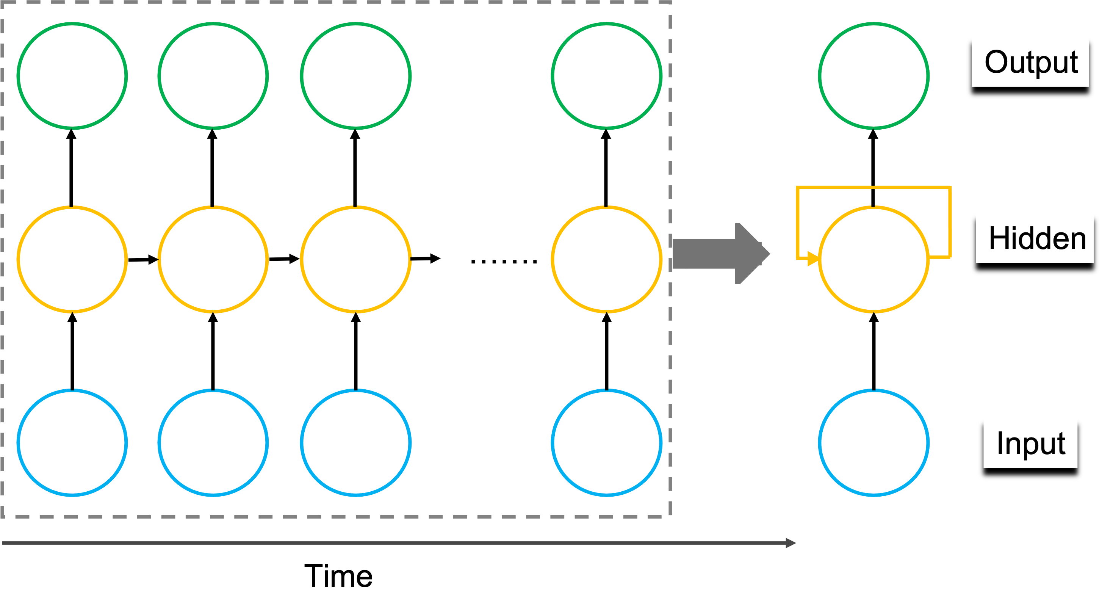
Figure 2: Schematic representation of RNN methodology.

Unlike other neural networks, backpropagation occurs at each time step known as back propagation through time (BPTT) adjusting and fitting the parameters of the model as it moves through each timestep (Lalapura, Amudha and Satheesh, 2021). This form of back propagation can lead to exploding gradients, where the gradient becomes too large leading to an unstable model, and vanishing gradients, where the gradient is so small as it updates it becomes insignificant and the algorithm is no longer learning (What are Recurrent Neural Networks? | IBM, ; The Vanishing/Exploding Gradient Problem in Deep Neural Networks | by Kurtis Pykes | Towards Data Science). Ways around these issues include reducing the amount of layers, gradient clipping and weight initialization, but for the purposes of this study, one of the best methods is using LSTM RNN.
5.LSTM

LSTMs were first introduced by Hochreiter and Schmidhuber in 1997 working well on a large variety of problems as they became refined (Understanding LSTM Networks -- colah’s blog, 2015). LSTMs illustrate their power by solving the Long term memory problem which describes the gap between information which was trained higher up the model hierarchy and required to be recalled for prediction at a later stage which leads to a situation where the RNN cannot learn to connect trained input with predicted output. LSTM architecture is more complex than standard RNNs which enables long term memory by using special gates known as the input gate, forget gate and output gate which facilitate the dropping of unimportant information and the retention of important information through the multiple nodes and layers of the model (Understanding LSTM Networks -- colah’s blog, 2015). These three gates protect and control the cell state of each node ultimately defining the output to the next node. The sigmoid layers in an LSTM generate values between 0 and 1, the closer to 0 means the information is less likely to make it through, while the closer to 1 means it will make it through to the output layer (Understanding LSTM Networks -- colah’s blog, 2015). LSTMs have been applied to several different types of data and have been used in the weather prediction, stock market prediction and even has been applied to Covid19 data to predict the spread in different countries (Braun, 2018; Qiu and Fan, 2021; Chandra, Jain and Chauhan, 2022; Srivastava and Anto, 2022). With the power of these models apparent, harnessing them in the world of big data will be of great benefit to answering important questions.

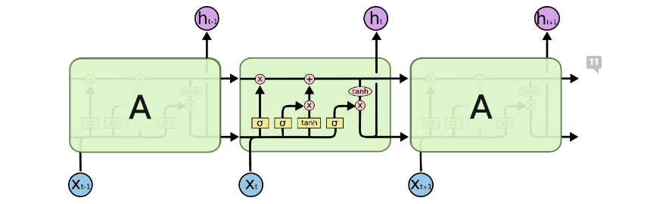

Figure 3: Architecture of LSTM. As shown in the central node the information much pass through the three types of gates present in an LSTM node thus dictating whether the information will be passed to output and make it to the next node.

6.Machine learning in a distributed environment

Despite these major advances in the field of big data and deep learning, platforms like Apache spark cannot yet support implementation of deep learning models such as LSTMs in the distributed environment due to the importance of the sequential nature of the data. The two can however be coupled to query and process big data to prepare it for implementation into RNN models thus providing a way to work around this issue at present. The current study highlights the use of Apache spark to query and process a dataset which models big data measurements such as precipitation and temperature at Knock airport. After processing the data was used to train RNNs to accurately predict temperature at Knock airport.

Methods

Overview of approach: To demonstrate how Apache spark could be used to process Big data and prepare it for use in advanced machine learning models, a code file and video of the implementation of apache spark specifically using sparksql and spark functionality to clean and process the dataset before conversion into pandas dataframe is provided (Filenames:CA1_AdvDA_BigDA_Sem1_Gdavis_SparkDeepLearning_20230405.ipynb,CA1_sba22311_GavinDavis_ImplementationVideo_20230412.mov ). After processing the data using Spark the data was converted to a pandas dataframe for use in training and testing a RNN models which could accurately predict temperature at knock airport based on historical data.

Programming tools: Data was processed using Apache spark on an ubuntu virtual machine with linux OS in combination with Jupyter notebook for python code execution and deployment. Programming libraries such as Keras, TensorFlow, matplotlib, seaborn and pandas were used following processing of data with Apache spark.

Data sources: Knock airport data was sourced from data.gov as a csv file and used a model dataset to provide an example of how big datasets could be processed using Apache spark and specifically pyspark to process, query and prepare big data for implementation into deep learning models such as neural networks. No permissions or licenses were necessary for acquiring this data which was freely available.

Big data processing: Apache spark is an open-source distributed computing platform used to store, process and clean the data containing Knock airport weather parameters. A detailed explanation of the processing of the data is given in Results Section 1.

Machine learning: Recurrent neural networks (RNN), specifically Long short-term memory models (LSTM) and SimpleRNN were used to generate a predictive models for temperature data in Knock airport. A detailed description of RNN implementation is given in Results Section 2.

Model evaluation: Three metrics were used to validate the model accuracies: MSE (mean squared error), RMSE (Root mean squared error) and R². Equations for how these metrics are calculated are shown below:

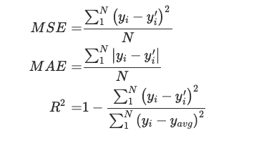
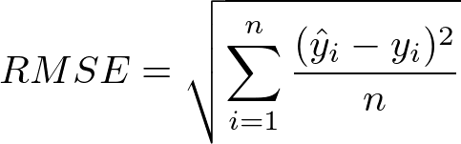

Results

1.Data processing with Apache Spark

To practically explore and process the Knock airport dataset, taking it as a model ‘big dataset’ to show how the big data platforms like Apache spark can be coupled to the implementation of an advanced neural network model, a linux OS system was used on the virtual box platform alongside jupyter notebook for the implementation of RNNs. Apache spark can be conveniently used with jupyter notebook through the pyspark API with a Hadoop distributed file system. A spark session was initiated and the dataset was imported from the Hadoop distributed file system where it was previously stored using the terminal. The Knock airport dataset was sourced from data.gov a database containing many datasets collected from Ireland. The dataset contained columns such as rain, temperature, windspeed, sunshine, visibility and importantly a date column which was easily assessed using pyspark “.describe” and “.printSchema” functions. As many of these parameters were unnecessary, given the parameter of interest was temperature, all columns except rain and temperature were removed from the dataset. Rain was retained to make sure operations were carried out on the whole dataset and to visualise a different parameter other than temperature as the data was being processed. Unnecessary columns were dropped using the ”.drop” function with date, temp and rain being retained. The columns were renamed as they were originally labelled incorrectly as _c1 to _c20. Null values were also removed from the dataset using “drop.na” function. All data in the dataset was string type meaning assessing descriptive statistics of the dataset was not possible. The rain and temp columns were converted to doubletype which is pysparks name for float type and the date column was converted to timestamp then to date type. The measurements were taken every hour on the hour from 1996 to 2023. A sample of the first 5 entries can be seen in Table 1. The shape of the dataset was assessed by using pyspark commands “.count” for rows and the length of the dataset columns in combination. The data set consisted of 232961 rows and 3 columns at this point. Generating a “quick overview” function to give the top values, the null value counts, the descriptive statistics of the dataset and the datatypes highlighted that there were no null values.
(A)
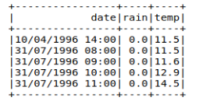
Table 1: Showing output from processed knock airport data using pyspark.

The minimum date after processing was 01/01/1997 and the maximum 31/12/2022 as seen in Table 2. The variable of interest temperature, “temp”, had a maximum value of 28.5 and a minimum value of -6.9 indicating a relatively large spread in the temperature values. The mean value was 8.69 and the standard deviation 4.6, indicating a large variance when considering the mean. After processing and performing the initial data exploration, the dataset was converted from a spark dataset to a pandas dataframe to generate a predictive model based on knock airport temperature data, which is detailed in the next section.

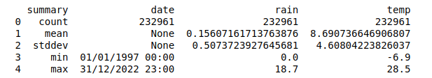

Table 2: Showing output from descriptive statistics in pyspark.

2.Implementation of neural network model for temperature prediction

After data processing with Apache spark the data was furtherly explored in a pandas dataframe format. The doubletype variables created during data processing in apache spark dataframe format were converted to float type when conversion to the pandas dataframe was completed. The date column was converted to datetime for time series analysis. A number of visualisations were prepared to visualise the temperature variable (“temp”) and the distribution of the variable as seen in figures 4 and 5. As shown the temperature variable is normally distributed signified by the bell-shaped curve in figure 4.
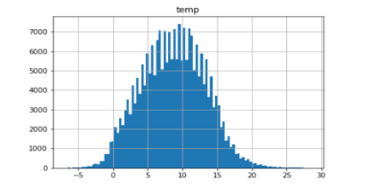
Figure 4: Histogram of temperature variable from Knock airport data

As shown in figure 5 (A) when plotting temperature against date the temperature varies uniformly around the mean of 8.7. However visualising seasonality in the data which we would expect from temperature measurements taken uniformly across a year cannot be seen here. Plotting the data as shown in figure 5 (B) highlights the seasonality of the temperature data with a seemingly fixed time interval as would be expected from temperature data across several years. The fixed time interval makes the prediction of the data slightly better given the regularity of the pattern.
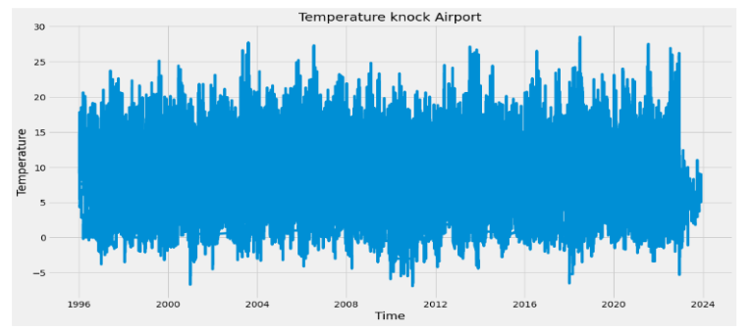
(B)
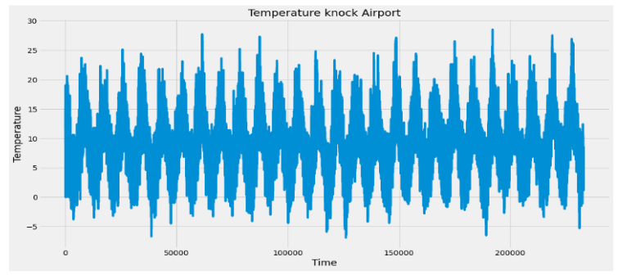
Figure 5: Histogram of temperature variable from Knock airport data
After this the temperature column was isolated and converted into an array, as TensorFlow only accepts data in this format. Eighty percent of the data was taking for training purposes consisting of 186369 rows/values. The data was scaled using the min max scaler from sklearn to get values between 0 and 1 which increase model accuracy, the values were unscaled when making predictions. The time step chosen was 30 for taking the data on a monthly basis. The X train data of 30 days of temperature values being used to predict the y_train values which was the 31st day. The x train data was converted into a 3-dimensional array as TensorFlow will only accept this format. The x_train shape was (186339, 30, 1) before model implementation. The LSTM model was chosen as the most appropriate model given its ability to deal with the long term memory problem discussed in the introduction section 5. The model was sequential for adding sequential layers, the first hidden contained 100 neurons as did the second hidden layer. A dropout layer of 0.2 (or 20%) was chosen as a penalty term making the network less sensitive to specific neurons and more likely to pick up the real trend, also reducing the chance of overfitting the model. A dense layer was included to fully connect the model and a final output layer. The ‘adam’ optimizer was chosen as it is the most commonly used and reliable, with mean square error as the loss function. The model was fitted with a batch size of 365 using 10 epochs. The results are shown in figure 6.

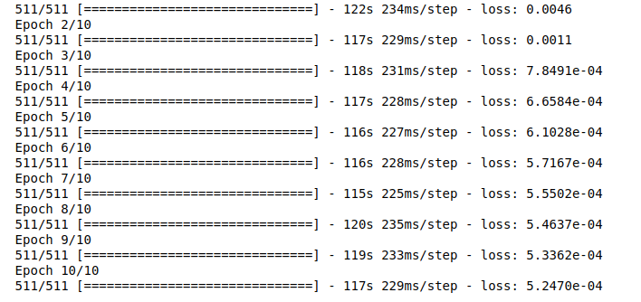

Figure 6: Output from LSTM model

As shown the loss decreases from a starting 0.0046 to 0.000524 in the 10th epoch indicating an approximate 10-fold decrease in loss, which signifies that the model is learning and becoming more accurate. The model takes approximately 20 minutes to run through 10 epochs. The RMSE for the model was calculated as 0.82 with an R squared value of 0.9696. The predictions overlayed on the actual values, along with valid predictions can be visualized in Figure 7. (A) shows valid predictions while (B) shows the predictions made by the model using the training data. Given the volume of data it is quite difficult to observe the granularity of the data and how close actual and predicted values are to one another. Considering this Figure 8 shows the last 30 days of the model with the real data versus the predictions.

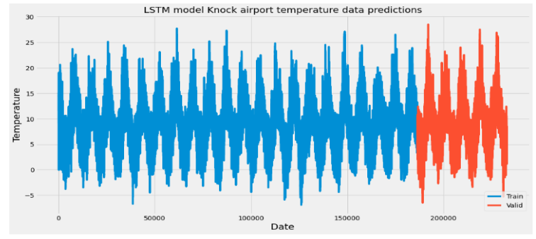
(A)
(B)
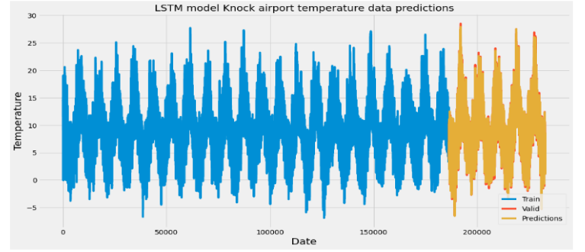

Figure 7: Valid predictions and predictions from LSTM model for knock airport temperature.

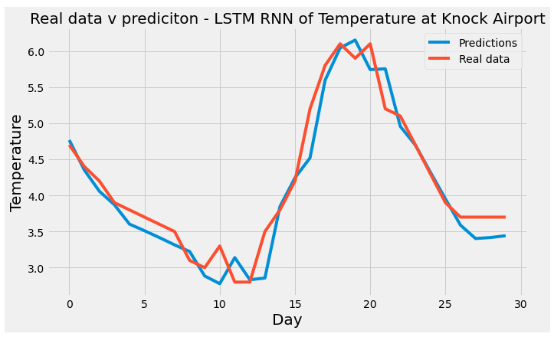

Figure 8: Final 30 days of temperature data at knock airport plotted alongside LSTM predicted values.

As shown in figure 8, the predictions in blue map to the real data in red closely but not perfectly indicated the model is seemingly accurate in line with the loss, RMSE and R squared. The model was then used to make a prediction for the temperature on the last day in the dataset. The model predicted 3.45. The actual last day was 3.7 indicating that the model is modestly accurate.

To compare the LSTM model against a normal recurrent neural network a Simple RNN was applied to the data to inspect any differences in speed, loss, R² and RMSE. SimpleRNN from Keras was applied with a hidden layer of 100 and the activation function ‘relu’. Again, mean squared error was chosen as the loss and the optimizer as ‘adam’. Interestingly, the SimpleRNN loss started lower at 0.0014 finally finishing on 0.000308 at the 10th epoch. Each epoch ran in approximately 30 seconds nearly 5 times faster than the LSTM model. The RMSE was 0.62 and the r squared was 0.98. The predicted value for the last day was 3.55 which was a closer prediction than the LSTM highlighting the increased accuracy of the model. Taken together considering the enhanced speed and reduced loss these results indicate that the SimpleRNN is a better modal which is an interesting finding given the widely claimed increased accuracy of LSTM models.

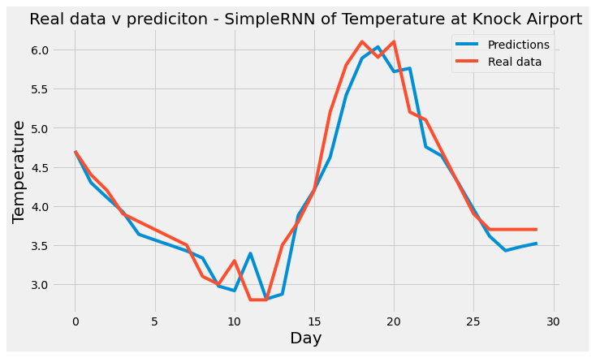
Figure 9: Final 30 days of temperature data at knock airport plotted alongside SimpleRNN predicted values.

Overall, the results indicate that both models are accurate but not perfect. The SimpleRNN appears to be more accurate than the LSTM model with a faster overall running time making it the more practical model. Given the length of the running time for the LSTM GridSearchCV was impractical for use.Further work will be needed to optimize these models fully along with optimal parameter searches using GridSearchCV..

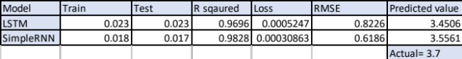

Table 3: Model metrics comparing LSTM with SimpleRNN

Discussion:

The current study highlights the disconnect between big data platforms and cutting-edge time series models such as neural networks. The aim of the study was to use a big data platform such as Apache Spark to process and prepare time series data consisting of knock airport weather measurements. Following this the data was implemented into RNNs with the aim of predicting temperature at Knock airport. Time Series analysis for weather forecasting has been experimented with in many studies in recent years. Several studies have focused on short term weather prediction using LSTMs. Suleman et al. 2022 compared several types of LSTM models alongside GRU and SVR models and found that Spatial Feature Attention-LSTM (SFA-LSTM) model was the most accurate with the lowest MSE and MAE (Suleman and Shridevi, 2022a). The model captures spatial and temporal relations of different meteorological features to forecast temperature with a R squared of 0.9996 and an MSE of 0.0871. This model was used to accurately predict temperature using 24-, 48- and 72-hour temperature data inputs to predict 1, 2 and 3 hours ahead. The SFA-LSTM had the lowest MSE and MAE under all circumstances (Suleman and Shridevi, 2022a). This study highlights how spatial features can be incorporated into LSTM and/or SimpleRNN to produce a model with greater accuracy, which may be of use in increasing the accuracy of the models presented in this study.

Another study harnessed bidirectional LSTM to predict atmospheric temperature (Hao et al., 2022). In this study, the authors highlight the contribution of dew point temperature and atmospheric pressure to the increased performance of temperature forecasting models. The authors of this paper used an attentional mechanism to quickly reduce unnecessary information from the data before implementation into the BiLSTM (Hao et al., 2022). Perhaps incorporation of this attentional methodology would increase the accuracy of the models presented in this paper, while the inclusion of more features such as the SFA-LSTM presented by Suleman and colleagues also contributing to a better performing modal.

One interesting finding in this study is that the SimpleRNN performs better than the LSTM. LSTMs are widely considered to be more accurate and as described, having been extensively used in weather forecasting (Hewage et al., 2019; Hao et al., 2022; Suleman and Shridevi, 2022b). The enhanced processing speed and accuracy metrics of the SimpleRNN compared to the LSTM was surprising and suggests that the SimpleRNN is a better modal with an R² of 0.98 vs 0.96. All other accuracy metrics favoured the SimpleRNN which importantly after 10 epochs had a lower loss (LSTM = 0.000526 v SimpleRNN = 0.000308). One possible explanation for this is the reduction in complexity from LSTM to SimpleRNN which would likely increase processing speed of the large volume of data. The slow speed (~20 minutes) for the LSTM to run could be increased by running this model in a distributed environment such as Apache spark. This highlights an important gap in the state of the art when it comes to harnessing big data for the generation of complex neural network based predictive models. The problem arises due to the sequential nature of time series data and running a model like an RNN across a distributed system. This will undoubtedly be an important area of research in the coming years as bridging this gap will lead to more accurate models generated from big data with enhanced processing speeds.

Fathi et al. 2021 cite that big data will become indispensable for generating more accurate weather forecasting models (Fathi et al., 2022). In this systematic review on big data analytics in weather forecasting they highlight that many algorithms were not originally designed to operate in the parallel computing environments, such as those provided by MapReduce and Apache spark (Fathi et al., 2022). The current study exemplifies this disconnect. Although similar analytics to process and prepare data for complex machine learning algorithms is provided by Apache spark, the machine learning algorithms for time series analysis themselves cannot be run in the distributed environment. This highlights a limitation of big data platforms and a blockade in application of advanced ML techniques on big data.

The power in weather forecasting is evident when considering the advantages in being able to predict meteorological events which can contribute to climate disasters. Climate change is something which effects the whole world and the application of deep learning algorithms to generate more accurate and effective predictive models will be imperative in the years ahead (Bochenek and Ustrnul, 2022). Another area where more advanced predictive models will be of great benefit is the effective use and generation of renewable energy generated from solar power and wind power (Bochenek and Ustrnul, 2022). Although the current study generated a model for prediction of temperature, the methodology in theory could be applied to any meteorological output, thus providing a way to predict sunshine and wind for their respective resource in energy production. Nearly all modern weather forecasting is performed by NWP models (Numerical weather prediction) which rely on using equations to describe the atmosphere and oceans, relying heavily on the temporal deliverance of spatial meteorological data to the point of interest (Dubey, 2022). Schultz et al. 2021 highlight that deep learning algorithms could effectively replace NWP models in the near future (Schultz et al., 2021). Schultz and colleagues highlighted how advanced models such as CNNs have been used to analyse satellite imagery for weather patterns (Schultz et al., 2021). Another study paired convolutional neural network principals with LSTMs to predict local and immediate precipitation levels (Shi et al., 2015). Here is where devising a way to harness big meteorological data for incorporation into advanced deep learning models will help advance the state of the art in weather forecasting, benefiting multiple sectors.

The benefit of generating advanced weather prediction models for industries such as transport, agriculture and many more is clear. With models that predict immediate and long-term weather patterns, better planning and strategy can be put in place for virtually every industry. Given our most advanced machine learning techniques for time series analysis at present take the shape of neural networks, and the vast amount of meteorological data, which is generated every minute of every day, bridging the gap between these two areas has never been more important.

Conclusion

In conclusion, this research has highlighted that both LSTM and SimpleRNN can be effectively implemented for temperature forecasting models using weather data from Knock airport. To highlight how big data can be paired with advanced ML techniques the data was processed and prepared in a distributed computing environment enabled by Apache spark. Although the Knock airport dataset was a model dataset using Apache spark in combination with advanced deep learning techniques, as shown, is possible. Interestingly, and contrary to the vast majority of literature attempting these types of models, the SimpleRNN was more accurate and practical than the LSTM model. The SimpleRNN’s runtime was much faster than the LSTM run time, with increased accuracy metrics and reduced RMSE and Loss, as shown in Table 3. Taken together this study provides a work around solution for pairing advanced machine learning techniques such as RNNs with big data platforms like Apache Spark, but much more work will be needed in fully connecting these technologies when dealing with bigger datasets.

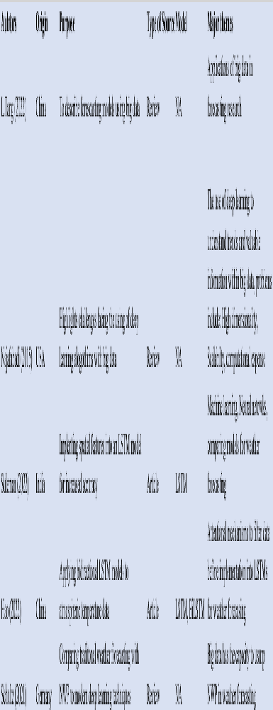
Table 4: Key papers connected to this research.

References

Bandi, R., Amudhavel, J. and Karthik, R. (2018) ‘Machine Learning with PySpark - Review’, Indonesian Journal of Electrical Engineering and Computer Science, 12(1), pp. 102–106. doi: 10.11591/IJEECS.V12.I1.PP102-106.
Bochenek, B. and Ustrnul, Z. (2022) ‘Machine Learning in Weather Prediction and Climate Analyses—Applications and Perspectives’, Atmosphere, 13(2), p. 180. doi: 10.3390/ATMOS13020180/S1.
Braun, S. (2018) ‘LSTM Benchmarks for Deep Learning Frameworks’. Available at: https://arxiv.org/abs/1806.01818v1 (Accessed: 5 April 2023).
Chandra, R., Jain, A. and Chauhan, D. S. (2022) ‘Deep learning via LSTM models for COVID-19 infection forecasting in India’, PLOS ONE, 17(1), p. e0262708. doi: 10.1371/JOURNAL.PONE.0262708.
Dash, S. et al. (2019) ‘Big data in healthcare: management, analysis and future prospects’, Journal of Big Data, 6(1), pp. 1–25. doi: 10.1186/S40537-019-0217-0/FIGURES/6.
Deb, C. et al. (2017) ‘A review on time series forecasting techniques for building energy consumption’, Renewable and Sustainable Energy Reviews, 74, pp. 902–924. doi: 10.1016/J.RSER.2017.02.085.
Dubey, A. K. (2022) Artificial intelligence for renewable energy systems. Woodhead Publishing. Available at: http://www.sciencedirect.com:5070/book/9780323903967/artificial-intelligence-for-renewable-energy-systems (Accessed: 14 April 2023).
Fathi, M. et al. (2022) ‘Big Data Analytics in Weather Forecasting: A Systematic Review’, Archives of Computational Methods in Engineering, 29(2), pp. 1247–1275. doi: 10.1007/S11831-021-09616-4/FIGURES/13.
Hao, X. et al. (2022) ‘Atmospheric Temperature Prediction Based on a BiLSTM-Attention Model’, Symmetry 2022, Vol. 14, Page 2470, 14(11), p. 2470. doi: 10.3390/SYM14112470.
Hewage, P. et al. (2019) ‘Long-Short Term Memory for an Effective Short-Term Weather Forecasting Model Using Surface Weather Data’, in IFIP Advances in Information and Communication Technology, pp. 382–390. doi: 10.1007/978-3-030-19823-7_32.
Karau, H. (2015) ‘Learning Spark [electronic resource] : lightning-fast big data analytics’.
Lalapura, V. S., Amudha, J. and Satheesh, H. S. (2021) ‘Recurrent Neural Networks for Edge Intelligence’, ACM Computing Surveys (CSUR), 54(4). doi: 10.1145/3448974.
Najafabadi, M. M. et al. (2015) ‘Deep learning applications and challenges in big data analytics’, Journal of Big Data, 2(1), pp. 1–21. doi: 10.1186/S40537-014-0007-7/METRICS.
Qiu, B. and Fan, W. (2021) ‘Machine learning based short-term travel time prediction: Numerical results and comparative analyses’, Sustainability (Switzerland), 13(13). doi: 10.3390/su13137454.
Sagiroglu, S. and Sinanc, D. (2013) ‘Big data: A review’, Proceedings of the 2013 International Conference on Collaboration Technologies and Systems, CTS 2013, pp. 42–47. doi: 10.1109/CTS.2013.6567202.
Schaffer, A. L., Dobbins, T. A. and Pearson, S. A. (2021) ‘Interrupted time series analysis using autoregressive integrated moving average (ARIMA) models: a guide for evaluating large-scale health interventions’, BMC Medical Research Methodology, 21(1), pp. 1–12. doi: 10.1186/S12874-021-01235-8/FIGURES/5.
Schultz, M. G. et al. (2021) ‘Can deep learning beat numerical weather prediction?’, Philosophical Transactions of the Royal Society A, 379(2194). doi: 10.1098/RSTA.2020.0097.
Shi, X. et al. (no date) ‘Convolutional LSTM Network: A Machine Learning Approach for Precipitation Nowcasting’.
Srivastava, A. and Anto, S. (2022) ‘Weather Prediction Using LSTM Neural Networks’, in 2022 IEEE 7th International conference for Convergence in Technology, I2CT 2022. Institute of Electrical and Electronics Engineers Inc. doi: 10.1109/I2CT54291.2022.9824268.
Suleman, M. A. R. and Shridevi, S. (2022a) ‘Short-Term Weather Forecasting Using Spatial Feature Attention Based LSTM Model’, IEEE Access, 10(July), pp. 82456–82468. doi: 10.1109/ACCESS.2022.3196381.
Suleman, M. A. R. and Shridevi, S. (2022b) ‘Short-Term Weather Forecasting Using Spatial Feature Attention Based LSTM Model’, IEEE Access, 10, pp. 82456–82468. doi: 10.1109/ACCESS.2022.3196381.
Tang, L. et al. (2022) ‘Big Data in Forecasting Research: A Literature Review’, Big Data Research, 27, p. 100289. doi: 10.1016/J.BDR.2021.100289.
The Vanishing/Exploding Gradient Problem in Deep Neural Networks | by Kurtis Pykes | Towards Data Science (no date). Available at: https://towardsdatascience.com/the-vanishing-exploding-gradient-problem-in-deep-neural-networks-191358470c11 (Accessed: 5 April 2023).
Understanding LSTM Networks -- colah’s blog (no date). Available at: http://colah.github.io/posts/2015-08-Understanding-LSTMs/ (Accessed: 5 April 2023).
What are Recurrent Neural Networks? | IBM (no date). Available at: https://www.ibm.com/topics/recurrent-neural-networks (Accessed: 5 April 2023).
What Is Hadoop & How Does It Work? | SAS Ireland (no date). Available at: https://www.sas.com/en_ie/insights/big-data/hadoop.html (Accessed: 5 April 2023).
Yamak, P. T., Yujian, L. and Gadosey, P. K. (2019) ‘A comparison between ARIMA, LSTM, and GRU for time series forecasting’, ACM International Conference Proceeding Series, pp. 49–55. doi: 10.1145/3377713.3377722.

